Clean Code Principles - Avoid Deep Nesting
# Source: AI Source: Provided by: [Data Path: Persons Table -> ID Column: 1, Name_En Column: Motasem Essam] -> From: [Chatgpt (GPT‑5 Mini)] on [12/9/2025]
Deeply nested code (many levels of if, for, while, or switch) is hard to read, understand, and maintain.
The goal is to flatten your code and handle special cases early.

🔑 Why It Matters
# Source: AI Source: Provided by: [Data Path: Persons Table -> ID Column: 1, Name_En Column: Motasem Essam] -> From: [Chatgpt (GPT‑5 Mini)] on [12/9/2025]
- Improves readability and clarity
- Reduces cognitive load
- Makes code easier to test and maintain
- Prevents bugs hidden in complex nesting

❌ Bad Example (Deep Nesting)
# Source: AI Source: Provided by: [Data Path: Persons Table -> ID Column: 1, Name_En Column: Motasem Essam] -> From: [Chatgpt (GPT‑5 Mini)] on [12/9/2025]
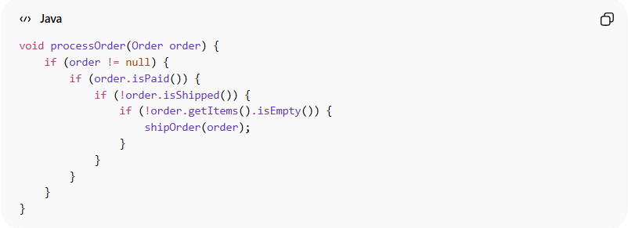
void processOrder(Order order) {
if (order != null) {
if (order.isPaid()) {
if (!order.isShipped()) {
if (!order.getItems().isEmpty()) {
shipOrder(order);
}
}
}
}
}
👉 Problems:
- Four levels of nesting
- Hard to follow the flow
- Hard to maintain or extend

✅ Good Example (Flattened with Early Returns)
# Source: AI Source: Provided by: [Data Path: Persons Table -> ID Column: 1, Name_En Column: Motasem Essam] -> From: [Chatgpt (GPT‑5 Mini)] on [12/9/2025]
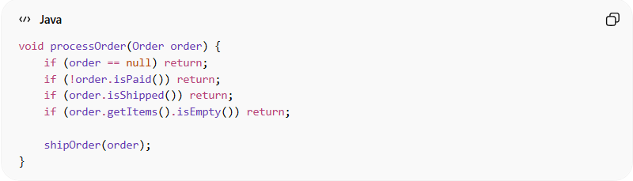
void processOrder(Order order) {
if (order == null) return;
if (!order.isPaid()) return;
if (order.isShipped()) return;
if (order.getItems().isEmpty()) return;

shipOrder(order);
}
✅ Benefits:
- Simple, readable flow
- Easy to see conditions at a glance
- Avoids deep indentation

✅ Another Approach: Extract Functions
# Source: AI Source: Provided by: [Data Path: Persons Table -> ID Column: 1, Name_En Column: Motasem Essam] -> From: [Chatgpt (GPT‑5 Mini)] on [12/9/2025]
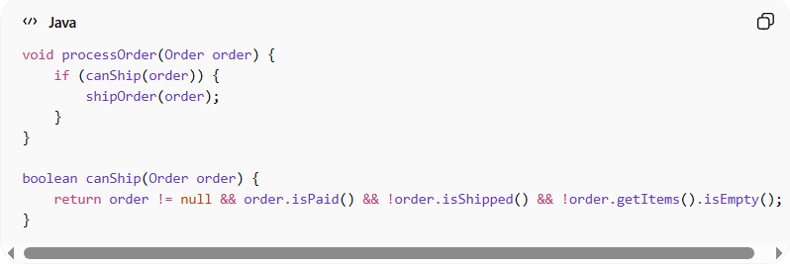
void processOrder(Order order) {
if (canShip(order)) {
shipOrder(order);
}
}

boolean canShip(Order order) {
return order != null && order.isPaid() && !order.isShipped() && !order.getItems().isEmpty();
}
👉 Logic is cleanly separated and easier to test

💡 Key Idea
# Source: AI Source: Provided by: [Data Path: Persons Table -> ID Column: 1, Name_En Column: Motasem Essam] -> From: [Chatgpt (GPT‑5 Mini)] on [12/9/2025]
Handle exceptions or special cases early, then focus on the main logic
Flatten code instead of nesting deeply

🚫 Common Mistakes
# Source: AI Source: Provided by: [Data Path: Persons Table -> ID Column: 1, Name_En Column: Motasem Essam] -> From: [Chatgpt (GPT‑5 Mini)] on [12/9/2025]
- Multiple nested if statements
- Combining multiple conditions inside loops
- Mixing business logic with validation checks

🧾 Summary
# Source: AI Source: Provided by: [Data Path: Persons Table -> ID Column: 1, Name_En Column: Motasem Essam] -> From: [Chatgpt (GPT‑5 Mini)] on [12/9/2025]
Avoiding deep nesting helps you write clean, readable, and maintainable code, making it easier for others (and future you) to understand the logic.

